**Determination of Valve Control**

The LRE can be throttled by controlling the propellant combustion rate (usually measured in kg/s or lb/s). By changing the propellant valves open margin this causes a reduction in the mass flow going into the main combustion chamber.

Valve Control of the system can be carried out in two ways. A closed loop feedback control system or an open loop non-feedback control system. Below are the descriptions of both systems characteristics with relevance to valve control.

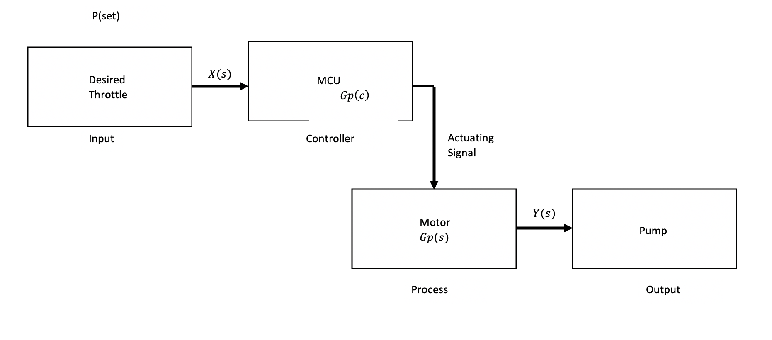**Open Loop Non-Feedback:**

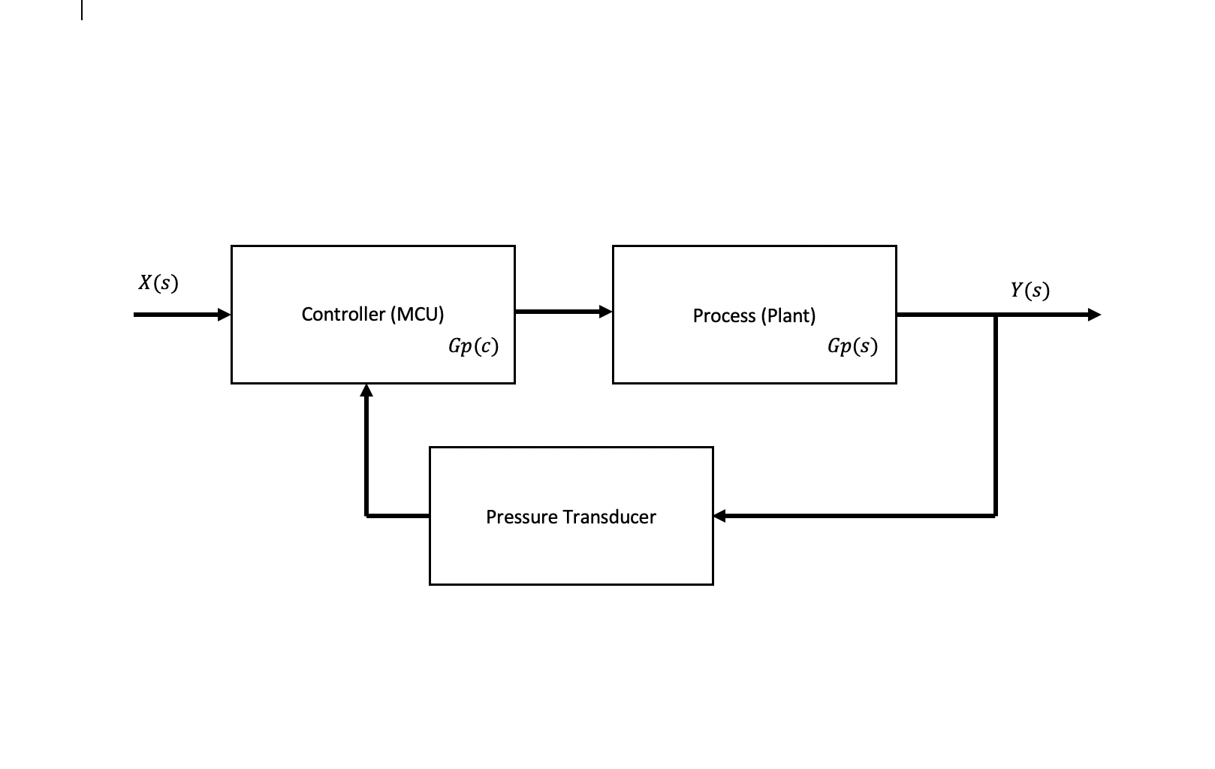**Closed Loop Feedback:**

These two systems can be used quite successfully independently, although a reliable direct approach will prove more favourable. As a result of differential pressure into the system as shown:

**Open Loop Feedback Control:**

Control using open loop feedback would require static actuator values placed as ranges. (0 = Closed) to (1 = Open) PWM Outputs to actuator.

Pressure Range Low (Approx.) = Actuator Range Low (Closed)

Pressure Range High (Approx.) = Actuator Range High (Open)

This however, is non feedback and can not respond to any inconsistencies in output.

**Closed Loop Feedback Control:**

Closed Loop Feedback control would employ a control algorithm, specifically PID. A PID controller continuously calculates an *error value*  as the difference between a desired setpoint (SP) and a measured process variable (PV) and applies a correction based on proportional, integral, and derivative terms (denoted *P*, *I*, and *D* respectively)